MVA among teenagers
Course:
Professor:
Date:
Introduction
Teen driving count for two thirds of the people injured or dead due to vehicle accidents. It is not necessarily the teens behind the when but also other road users e.g. passengers. In 2013, more than 370,000 teens got injured due to MVA related incidences and another 2, 927 died due to MVA (Preventing Teen Motor Crashes, 6).
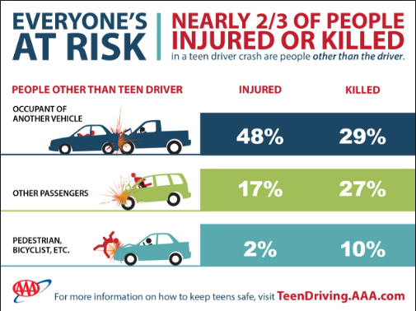
Specific health concerns of teenagers
Motor vehicle accidents are leading causes of death among teenagers in the United States of America. In the period of 2012, more than 1800 teenagers of the age 15-21 died in road accidents. Unintentional injury and behaviors that contribute to injury of teenagers affect the teenager’s health. Their psychology is also affected once they are involved in accidents and they survive (Gruber and Jonathan, 12).
Risk factors for teenagers
- Inexperience
- Teen passengers
- Drinking and driving.
- Driving during the night
- Diversion while driving, including from utilizing PDAs and texting
- Driving at exorbitant rates, and other dangerous driving
- Companions driving in an unsafe manner (Gadsden, et. al., 3).
Levels of prevention/control (Primary, Secondary, Tertiary)
Primary Prevention
Primary prevention methods of preventing MVA involves removing all the circumstances causing injury such as traffic speed reduction, reducing alcohol consumption etc. (Bonnie, et. al., 5)
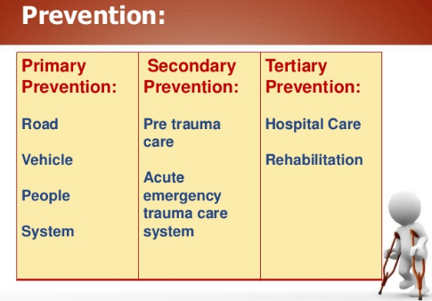
Secondary prevention
The secondary ways of preventing MVA include; reducing the impact of the injury in case it occurs. This include use of safety belts, helmets etc. while on the road (Bonnie, et. al., 5).
Tertiary prevention
The tertiary preventing methods of MVA include; the optimal treatment as well as the rehabilitation in case of injury. This involves administering first Aid and hospital care (Bonnie, et. al., 5).

Works cited
Bonnie, Richard J, and Mary E. O'Connell. Reducing Underage Drinking: A Collective Responsibility. Washington, DC: National Academies Press, 2015. Print.
Gadsden, Vivian L, Morgan A. Ford, and Heather Breiner. Parenting Matters: Supporting Parents of Children Ages 0-8. Washington, DC: the National Academies Press, 2016. Internet resource.
Gruber, Jonathan. Risky Behavior Among Youths: An Economic Analysis. Chicago: University of Chicago Press, 2016. Internet resource.
Preventing Teen Motor Crashes: Contributions from the Behavioral and Social Sciences : Workshop Report. Washington, D.C: National Academies Press, 2017. Internet resource.

